Hash Thermostat Guide
Step 1:
Connect to the WIFI access point “AP_Thermostat” the password is “StackSats!”
Note: WIFI access point deactivates when rebooted and device connects to network
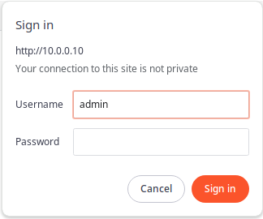
Step 2:
Open your web browser and navigate to http://10.0.0.10/
-Login prompt the username and password are “admin”
click “Sign In”

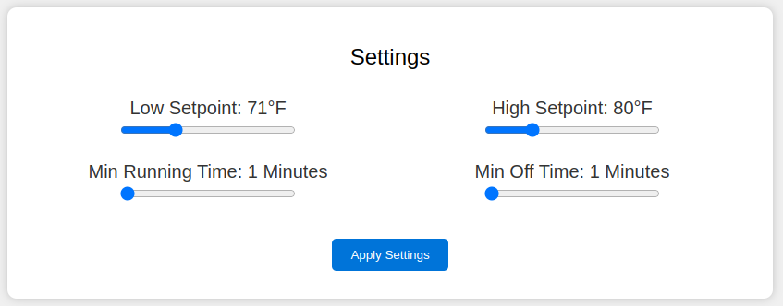
Step 3:
Enter the desired thermostat behavior using the sliders and click “Apply Settings”

Step 4:
Navigate to “Network Parameters”

-Enter Wifi SSID and Password and click “submit”
If network has connected you should see the Status change to “Connected” otherwise double check the credentials

-Enter the Miner Static IP and click “submit”
If the miner is connected the Status changes to “Hashing” or “Off” depending on the state

-Click the Time Zone dropdown to select your Time Zone and click “submit”

When all looks good, click “Main Page”

Step 5:
Change the Login Password

Step 6:
If you have an MQTT broker you want to send data to click “MQTT Parameters”

Step 7:
Click the “Reboot” Button
You should be able to find the device by typing “http://thermostat.local/” in the browser

